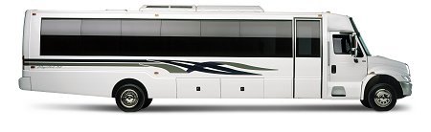
Party Bus Dallas

www.dallaspartybuses.com
PartyBusDallas@yahoo.com
214.586.1630 Reservations
817.566-2961 Fax
206.339.6151 E-Fax

Credit Card Authorization Form

Please fill in the following information:

credit card information: (circle one)

American Express/ Visa/ Master Card/ Discover
_______________________________ _________________ ____________
credit card number expiration date/ security code on back of card.

Cardholder Name as it appears on credit card: ___________________________________________
Billing Address for Credit Card __________________________________________________
____________________ __________________ _________________
City State Zip Code___________________
Contact Phone Number:_____________ ( ) Reservation # _______________
Base Rate: ___________ Service Charge @ 20%: _________
Total Charge: ________________

_______________________________________
Authorized Card Holder Signature

I, the undersigned, authorize Party Bus Dallas / B.T. Enterprises/affiliates to charge the above referenced credit card for transportation and related services. I understand that if a trip is cancelled within 10 days from event date or if the passenger(s) does not show up for the confirmed reservation, I will be billed the full amount of the trip. I understand that the deposit is non-refundable and will be forfeited. I also forfeit my right to all charge-backs proceedings. Please E-mail or E- Fax back this form with a copy of the front and back of the credit card, as well as copy f the Drivers License of the authorized person/cardholder.

